

Bottle Opener Installation

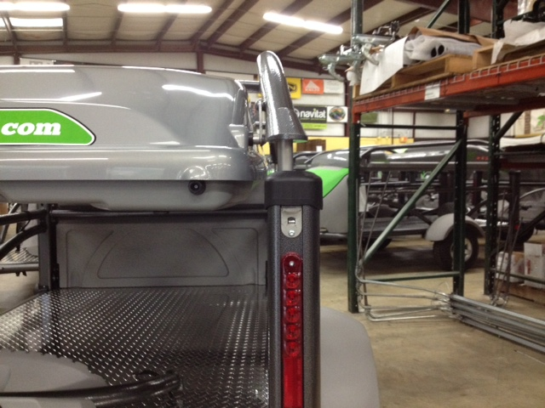

- Install the bottle opener directly under the rear lift tube cap.
- Clean the area thoroughly with rubbing alcohol.
- Drill a hole into the aluminum tube through the screw holes using a 5/32” drill bit.
- Secure with the provided screws.

